1. **Data Import**
2. Download **northwind-db.sql** from classroom
3. Open XAMPP and Click **Explorer**
4. Copy downloaded database to **mysql** folder.
5. Open Shell from XAMPP Admin Panel.
6. Create database **<yourname>northwind** and exit

**Query:**   
 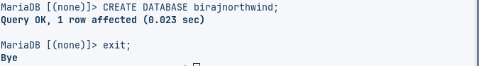

1. Import database in **<yourname>northwind** using following command at SHELL

**Query:**



1. Connect to database

**Query:**

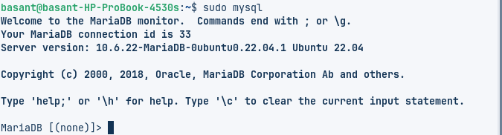

1. Use **<yourname>northwind** database using

**Query:**

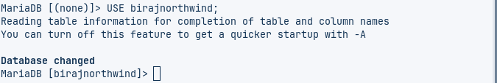

Show Tables  
 **Query:**

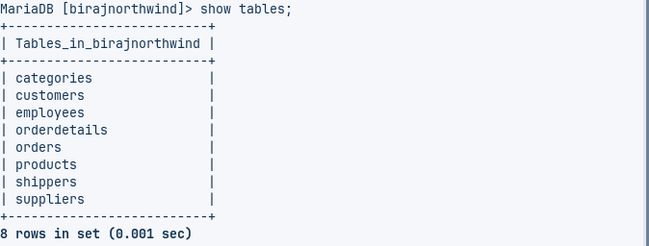

Check attributes and constraints in each tables with ER-Diagram:

**Categories**

**Query:**

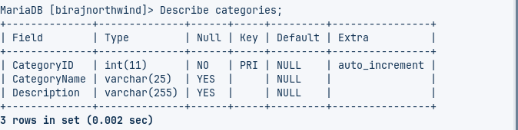  
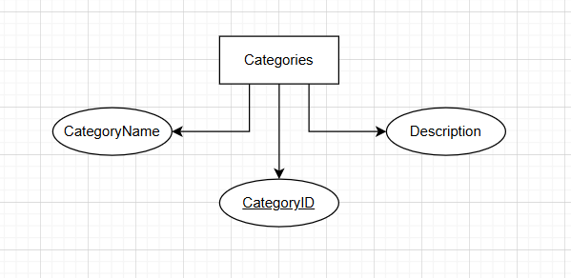

Customers

**Query:**

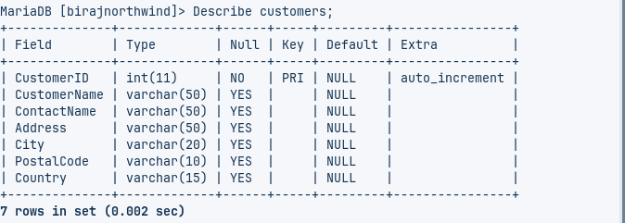  
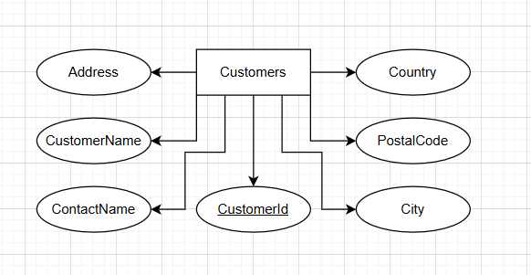

Employees

**Query:**

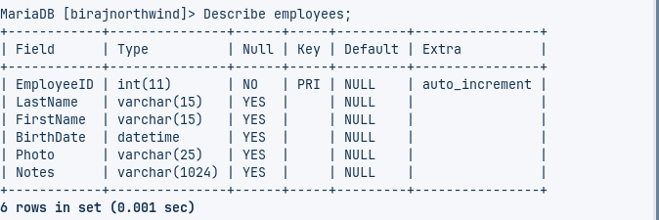

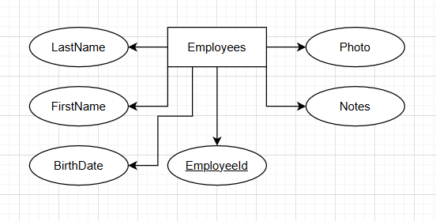

Orderdetails

**Query:**

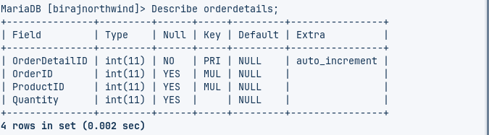

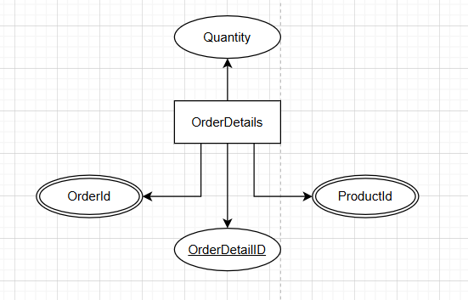

Orders

**Query:**

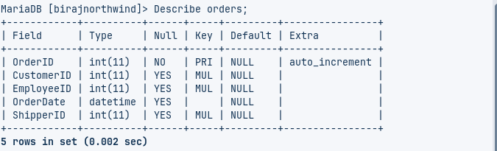  
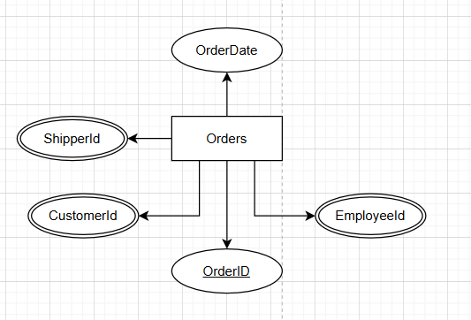

Products

**Query:**

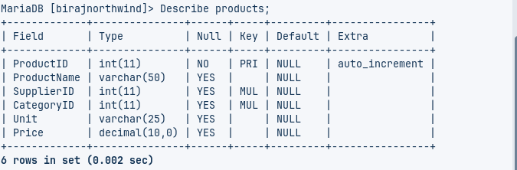

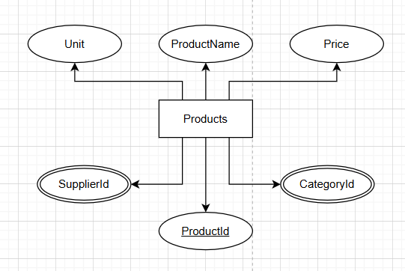

Shippers

**Query:**

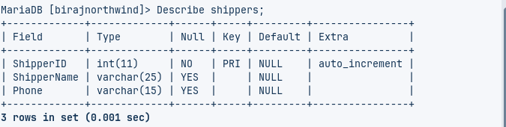

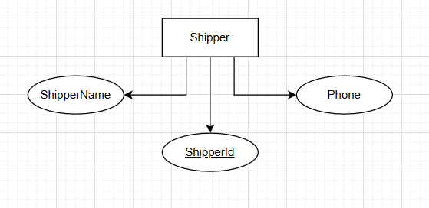

Suppliers

**Query:**

